剪刀、石頭、布

Rock, paper, scissors

在這個專案裡，你會製作一個Scratch版的剪刀、石頭、布遊戲。

In this project you will make Rock, Paper, Scissors in Scratch.

我們會用相機拍你的手來玩這個遊戲。

To have your move, you’ll take a photo of your hand.

但在這之前，你需要先訓練電腦辨識照片，讓它能分辨出你比的是剪刀、石頭還是布。

But first, you’ll need to train the computer to look at your photos and recognise the different hand shapes of rock, paper, and scissors.

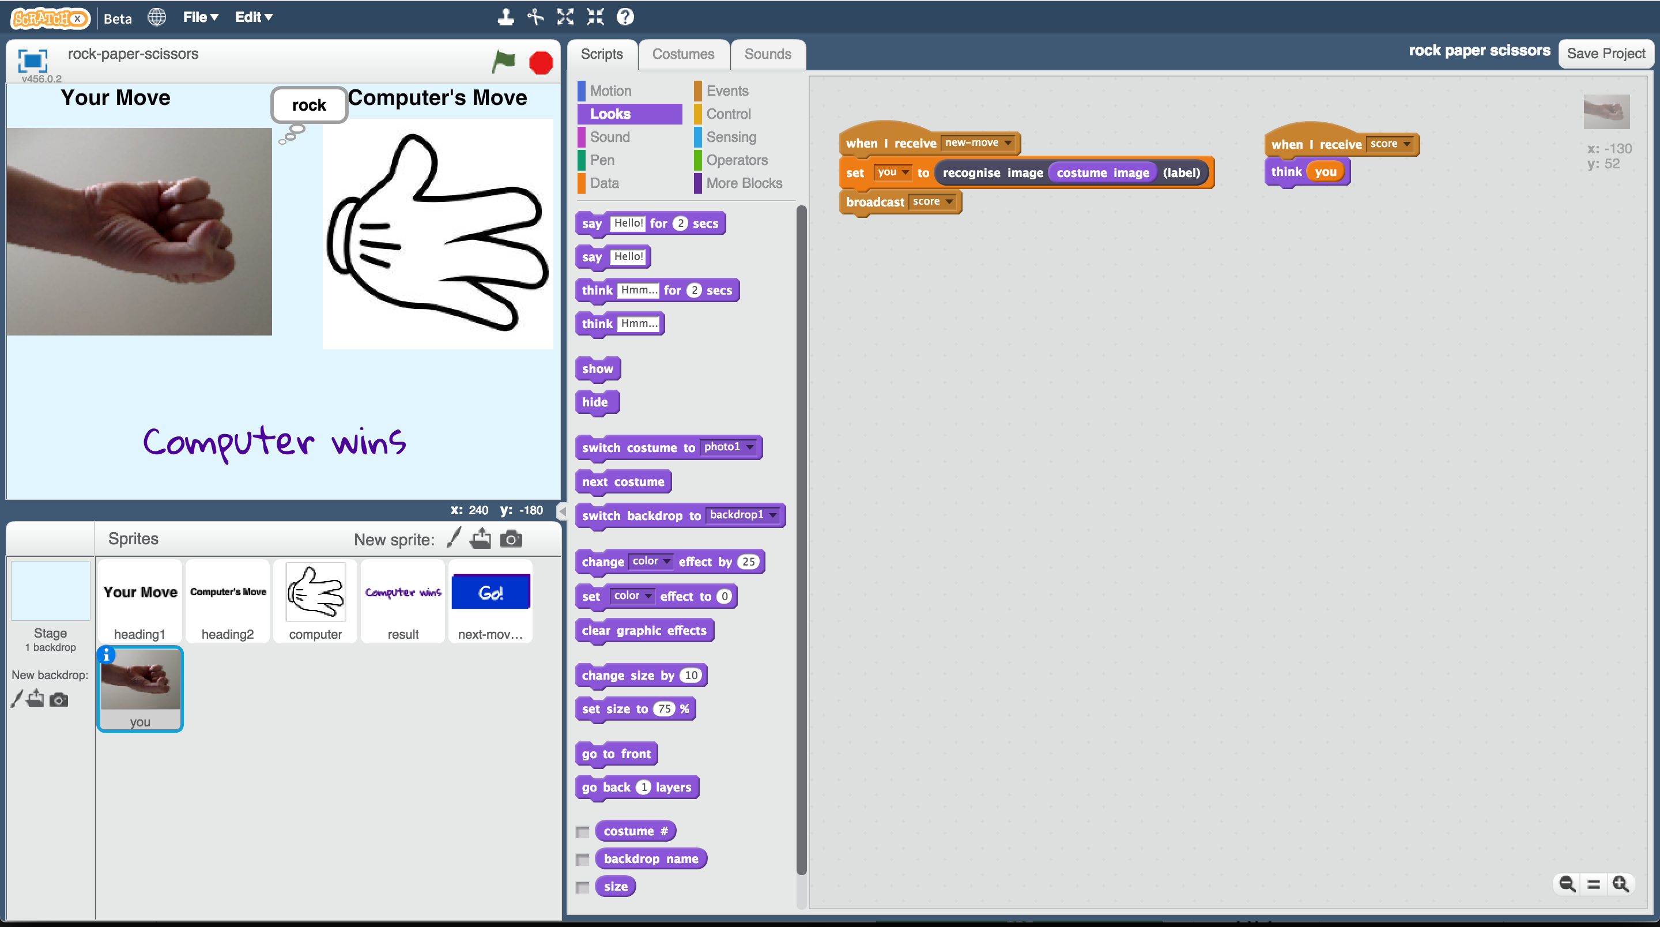

This project worksheet is licensed under a Creative Commons Attribution Non-Commercial Share-Alike License

http://creativecommons.org/licenses/by-nc-sa/4.0/

**這個活動需要拍攝你的手並上傳**

如果你不喜歡，請老師幫你換其他活動

**This activity will include you taking pictures of your hand & uploading them.**

If you’re not happy with that, ask your teacher or group leader for a different activity.

1. 搜尋網頁：<https://machinelearningforkids.co.uk/>

Go to <https://machinelearningforkids.co.uk/> in a web browser

1. 點選“**Get started**”

Click on “**Get started**”

1. 點選“**Log In**”按鈕並登入系統

*如果你沒有帳號，請你的老師幫你建立一個帳號。*

*如果你不記得你的帳號或密碼，請你的老師幫你重新設定一次。*

Click on “**Log In**” and type in your username and password  
*If you don’t have a username, ask your teacher or group leader to create one for you.  
If you can’t remember your username or password, ask your teacher or group leader to reset it for you.*

1. 點選上方清單中的 **”Projects”** 按鈕

Click on “**Projects**” on the top menu bar

1. 點選 “**+ Add a new project**” 按鈕

Click the **“+ Add a new project**” button.

1. 將你的專案命名為 “rock paper scissors”並設定成辨識 “**images**”類別

Name your project “rock paper scissors” and set it to learn how to recognise “**images**”.   
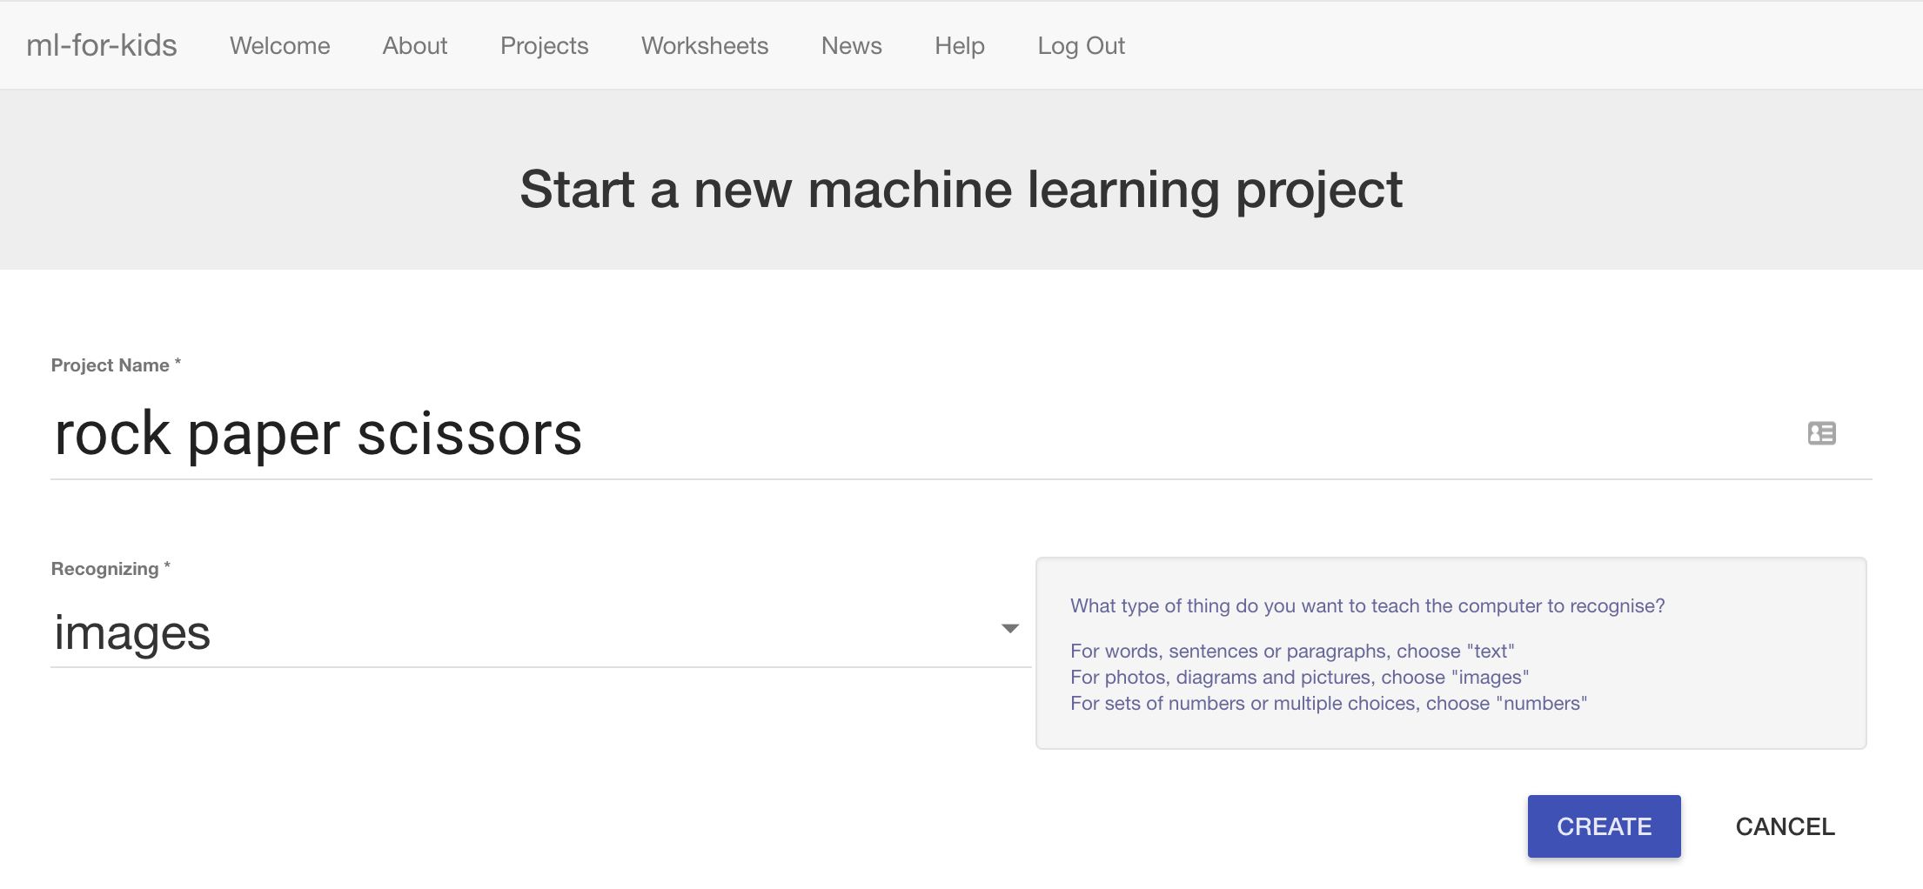

1. 點選 “**Create**”按鈕

Click the “**Create**” button

1. 你會在專案清單中看到“rock paper scissors”，點選此專案

You should see “rock paper scissors” in the projects list. Click on it.  
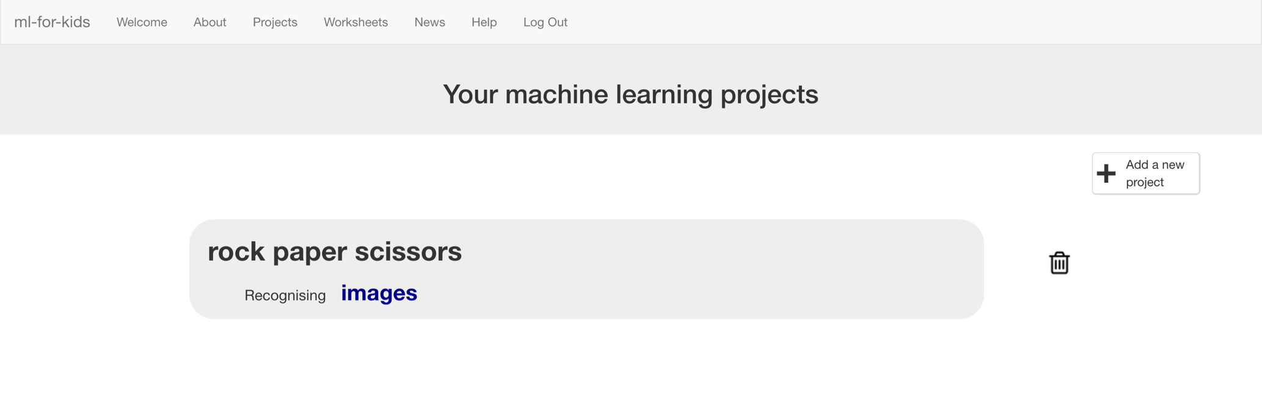

1. 點選 **”Train”** 按鈕

Click on “**Train**”  
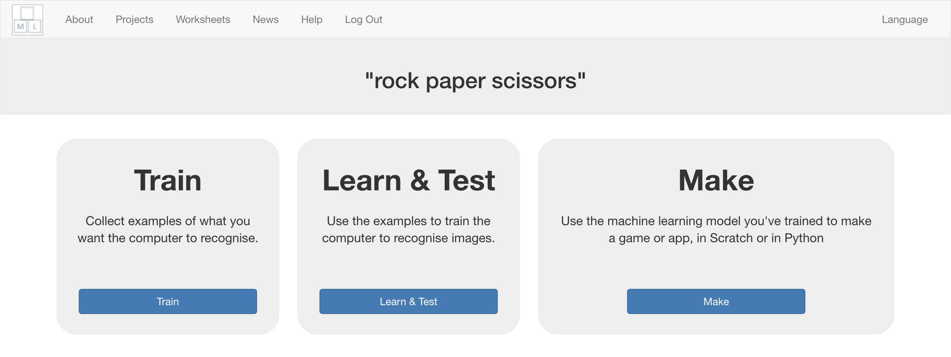

1. 點選 “**+ Add new label**”按鈕，建立一個名為” rock”的方框

Click “**+ Add new label**” and create a bucket called “rock”.  
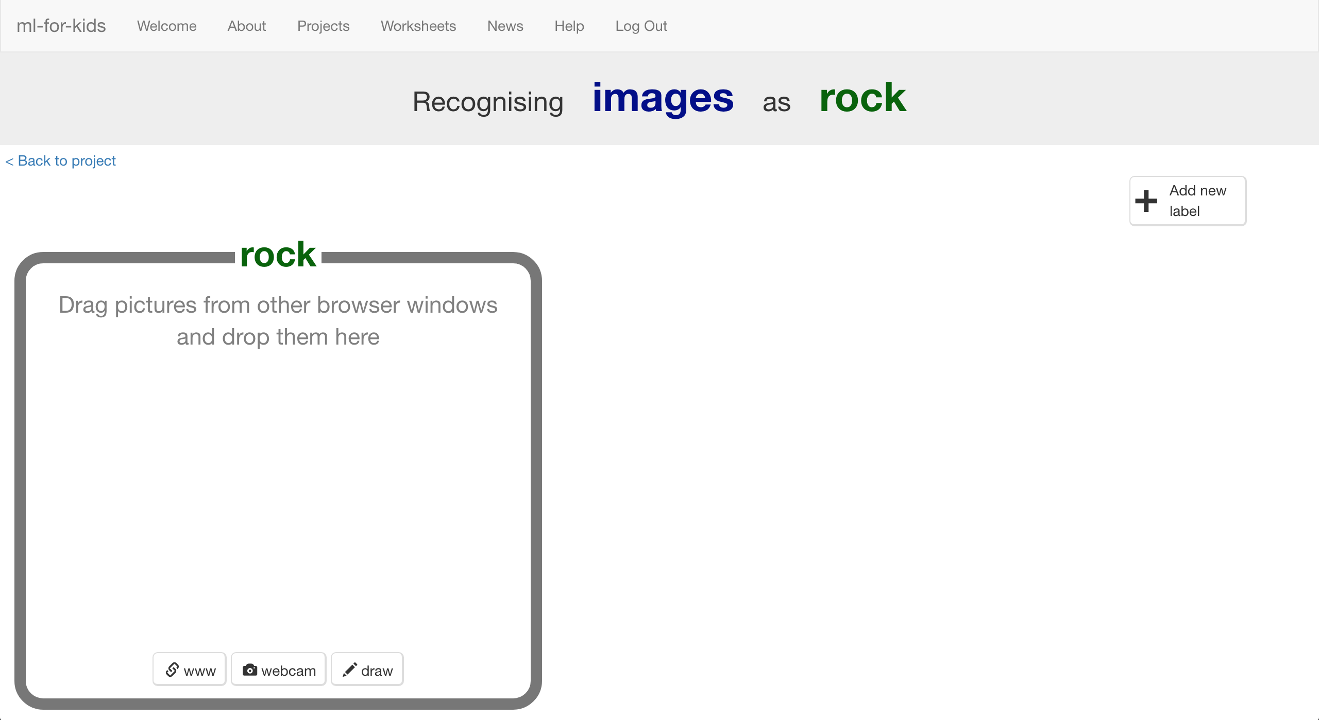

1. 點選“**webcam**”按鈕，預覽視窗裡會顯示出目前你的鏡頭所拍到

的畫面。

*如果你的瀏覽器要求存取權，點選『允許』*

Click “**webcam**”

*A Preview window shows the current view from your webcam.*  
*You will need to click “Approve” or “Allow” if your web browser asks permission to use your webcam.*

1. 在鏡頭前擺出石頭（握拳）的手勢

Make your hand into a “rock” shape (fist) in front of the webcam  


1. 點選“**Add**”拍張照片。

*如果能找到人幫忙，會比較好操作，你可以負責拍照，夥伴負責做動作。*

When you’re ready, click “**ADD**” to take a picture  
*If you’re doing this with a partner, it might be easier for one of you to click on “ADD” while the other makes hand-shapes.*

1. 點選“**webcam**”按鈕

Click “**webcam**” again  
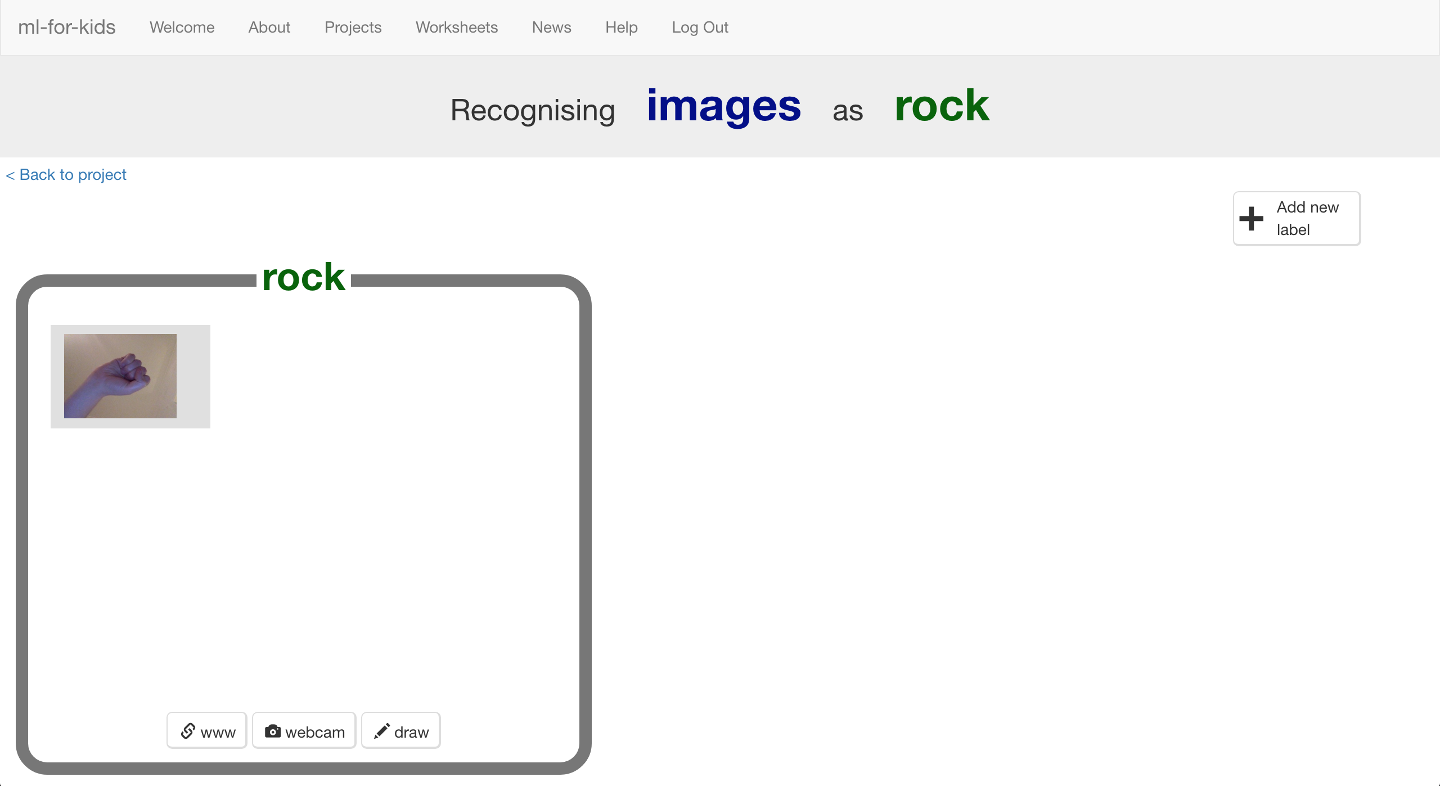

1. 重複直到至少有**10張**石頭（握拳）的照片

*盡量從不同位置、角度、距離拍攝，範例照片的差異性越高越好。*

Repeat until you’ve got **10** examples of a “rock” shape (fist).   
*Try to get a variety of positions, angles and sizes.   
The more variation the computer has to learn from, the better.*  
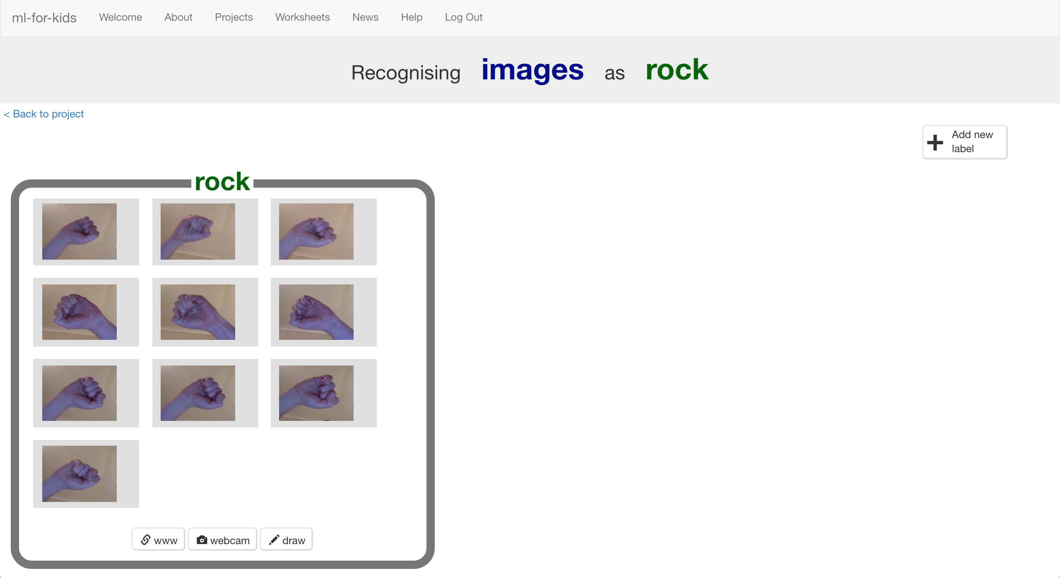

1. 點選“**+ Add new label**”建立一個方框，命名為“paper”

Click “**+ Add new label**” and create one called “paper”  
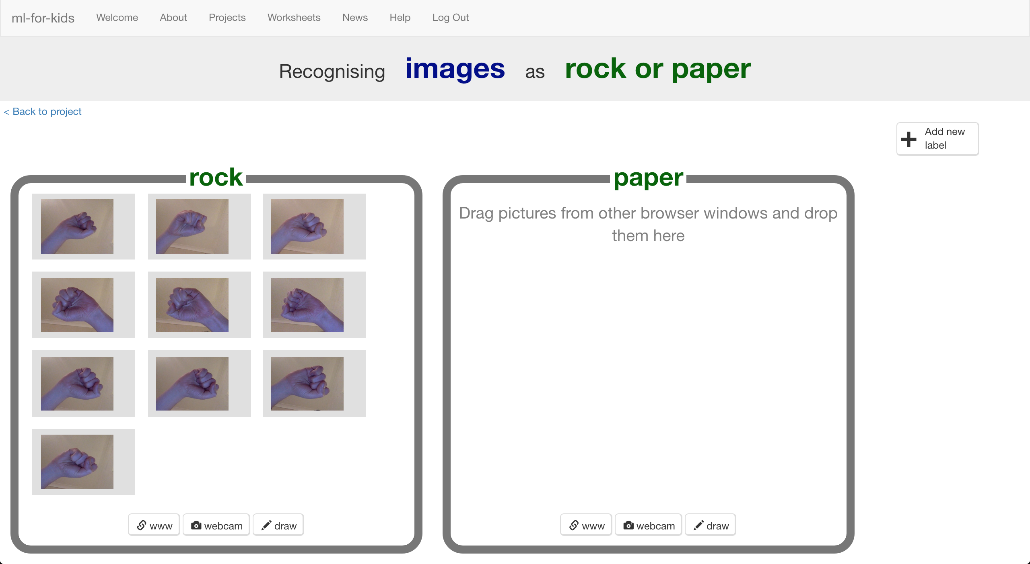

1. 點選“paper”方框中的“**webcam**”按鈕

Click the “**webcam**” button in the “paper” bucket

1. 點選“**ADD**”，拍張布（把手攤平）的照片

Click “**ADD**” for a photo of your hand in a “paper” shape (flat hand)

1. 重複直到至少有**10張**布（手攤平）的照片

*盡量從不同位置、角度、距離拍攝，範例照片的差異性越高越好。*

Repeat until you have **10** photos of your hand in a “paper” shape *Try to get a variety of positions, angles and sizes.  
The more variation the computer has to learn from, the better.*  
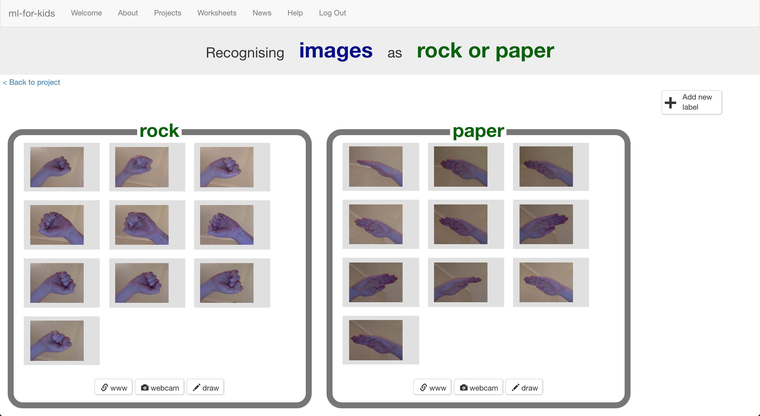

1. 點選“**+ Add new label**”建立一個方框，命名為“scissors”

Click “**+ Add new label**” and create one called “scissors”

1. 點選“scissors”方框中的“**webcam**”按鈕，拍**十張**手比剪刀的照片

Use the “**webcam**” button in the “scissors” bucket to take **10** photos of your hand in a “scissors” shape (two fingers).  
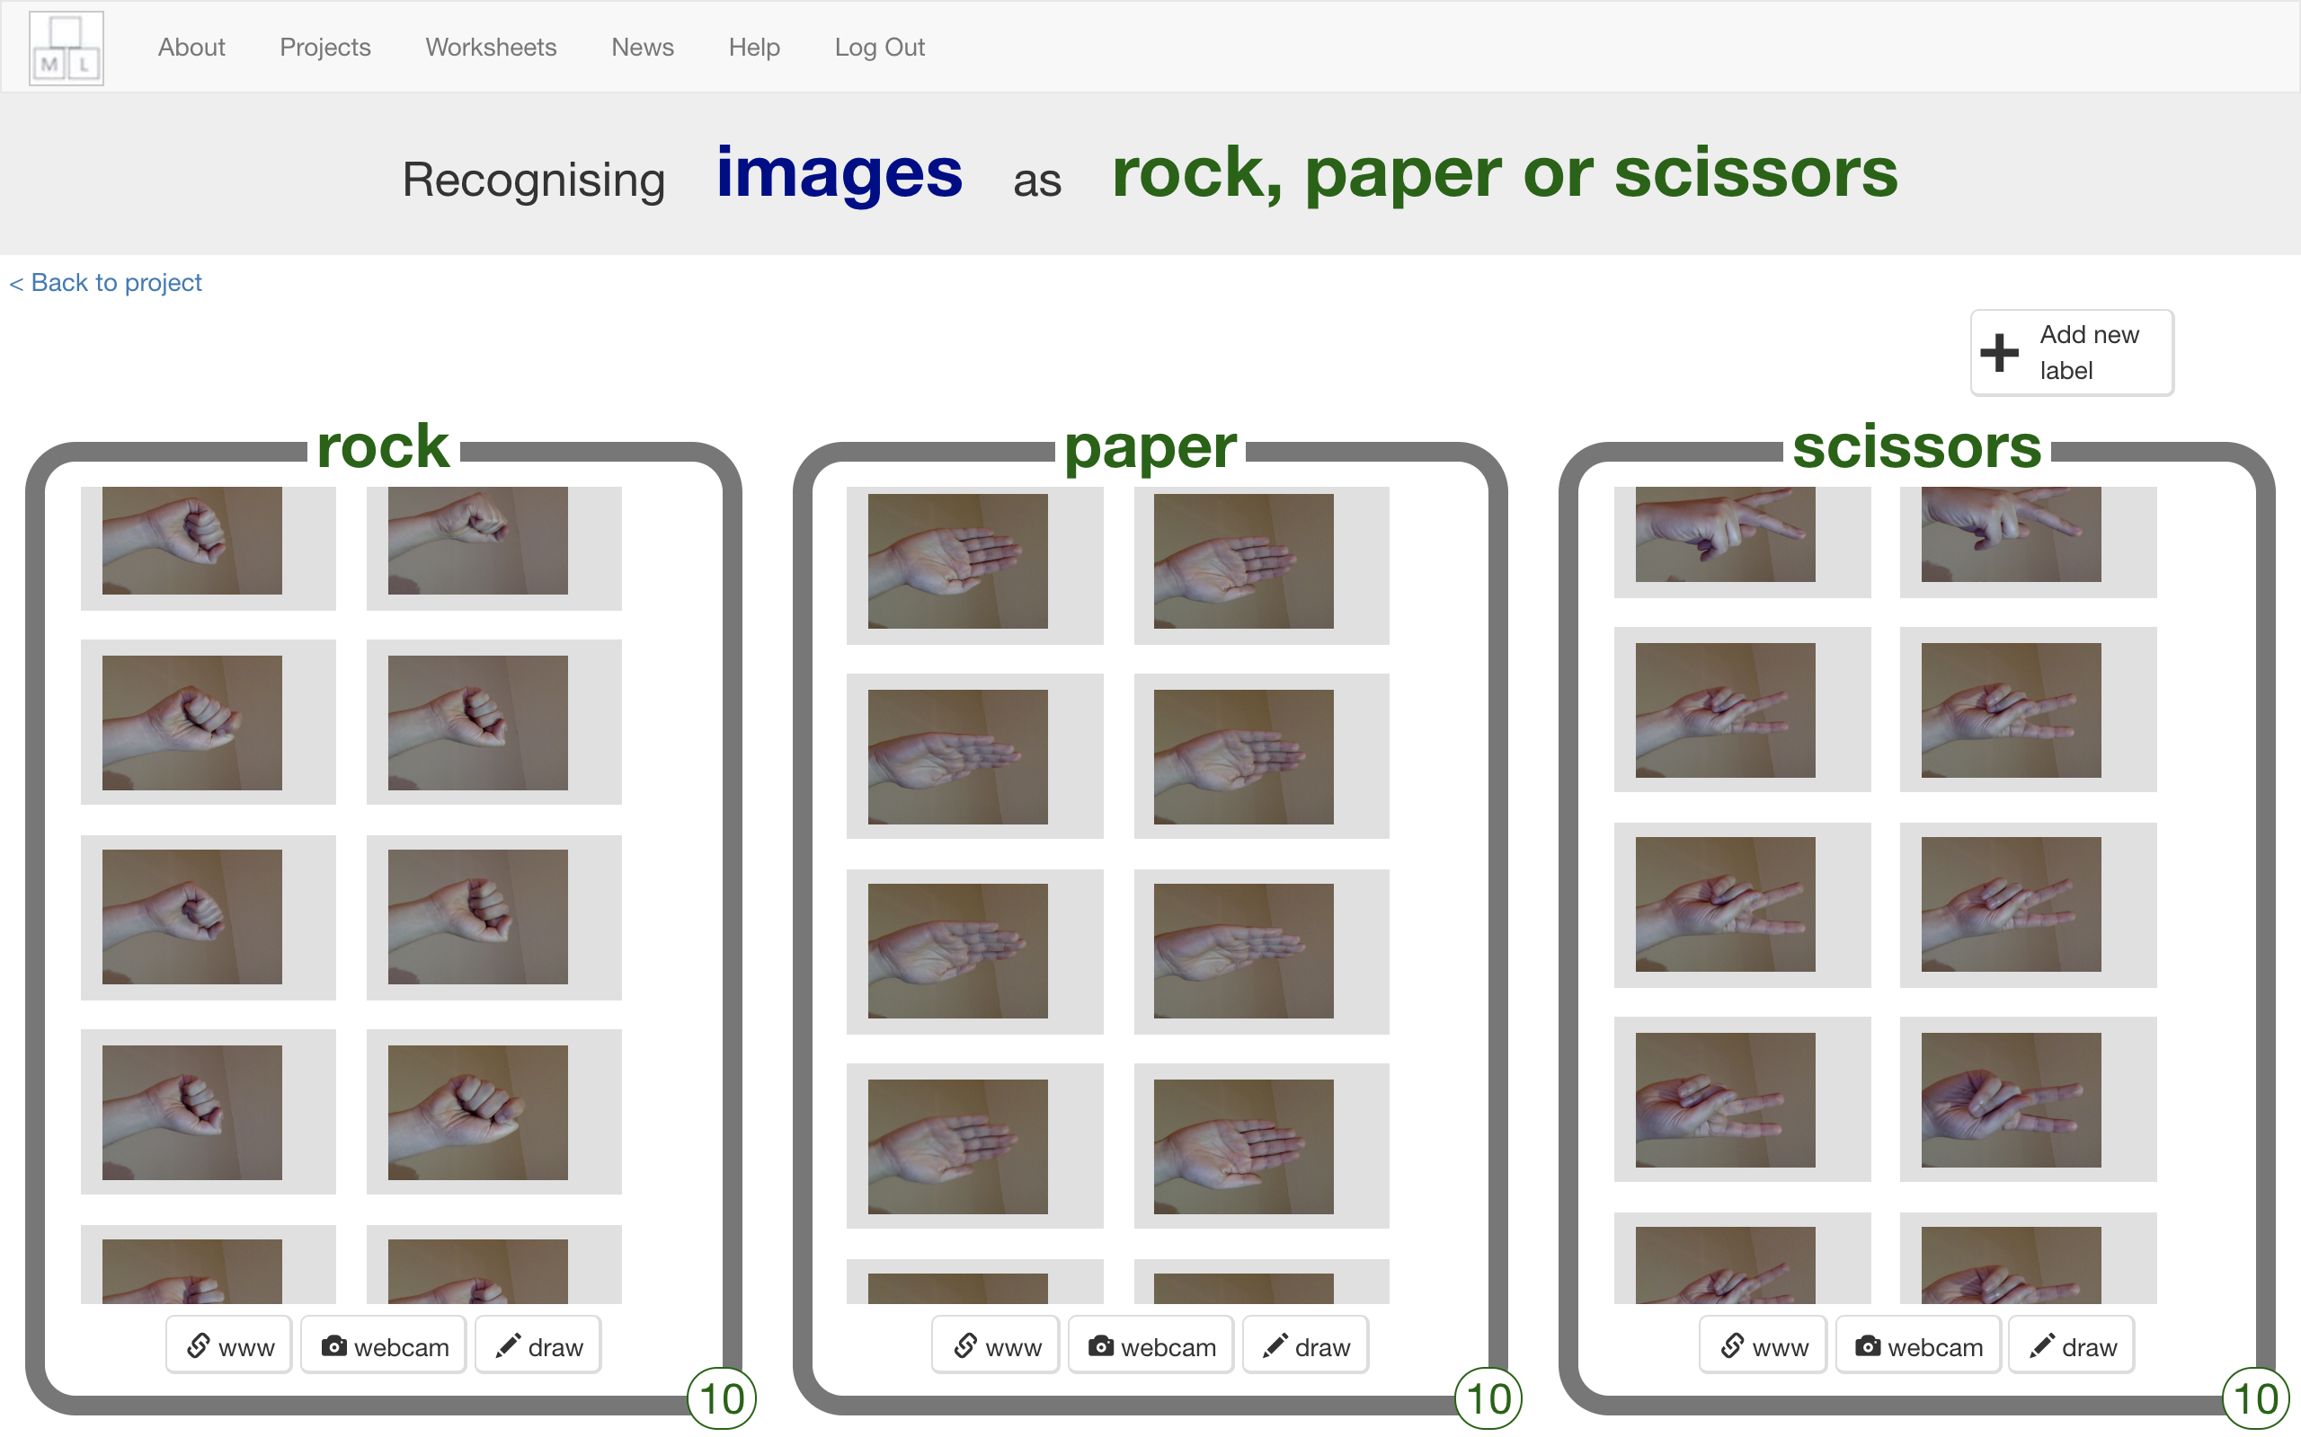

1. 點選“**< Back to project**”

Click the “**< Back to project**” link.

1. 點選“**Learn & Test**”按鈕

Click the “**Learn & Test**” button.

1. 點選“**Train new machine learning model**”按鈕

Click the “**Train new machine learning model**” button.   
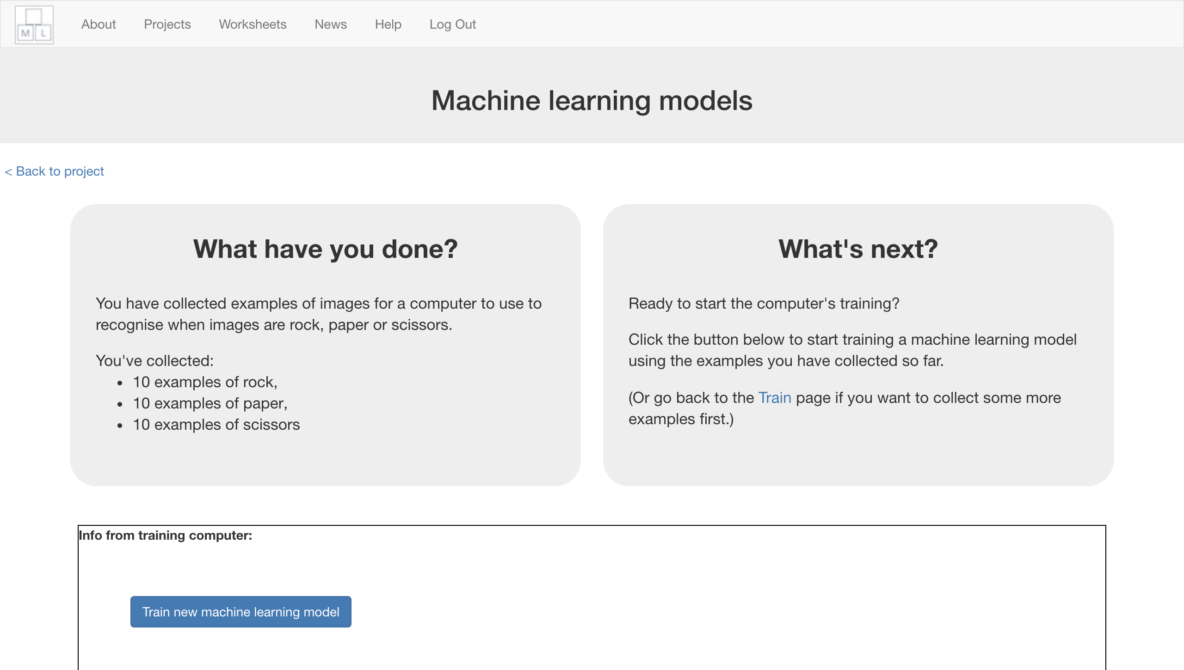

1. 等待訓練完成，此步驟可能需要花費幾分鐘的時間

Wait for the training to complete. This might take a few minutes.  
*While waiting, try the multi-choice quiz at the bottom of the page.*

1. 點選“**< Back to project**”

Click “**< Back to project**”

**到目前為止，你做了哪些事情？**

**What have you done so far?**

你蒐集範例照片來訓練電腦辨別手比剪刀、石頭、布的照片，這些範例會被用來訓練一個機器學習的 『模型』。

You’ve started to train a computer to recognise pictures as being rock, paper or scissors. You are doing it by collecting example photos. These examples are being used to train a machine learning “model”.

這就是所謂的『監督式學習』，因為你在這個過程中確保（監督）電腦收到的結果是正確的 (supervised learning)。

This is called “supervised learning” because of the way you are supervising the computer’s training.

電腦會從範例照片的顏色與形狀學習到一些模式。這些東西會被用來辨識新的照片。

The computer will learn from patterns in the colours and shapes from each of the photos you’ve given it. These will be used to be able to recognise new photos.

**小技巧**

**Tips**

**多一點範例！**

**More examples!**

當你給越多範例，電腦就應該能更正確的辨別照片中的手勢是剪刀、石頭還是布。

The more examples you give it, the better the computer should get at recognising whether a photo of your hand is rock, paper or scissors.

**盡可能蒐集相同數量的範例**

**Try and be even**

嘗試讓各個手勢的範例照片一樣多

Try and come up with roughly the same number of examples for each shape.

如果你其中一種照片特別多，那麼電腦可能會更容易將照片判別成這一類，因此會影響到電腦的學習

If you have a lot of examples for one type, and not the other, the computer might learn that type is more likely, so you’ll affect the way that it learns to recognise photos.

**確保範例中有各種圖片**

**Mix things up with your examples**

試著蒐集不同類別的範例

Try to come up with lots of different types of examples.

比方說，可以拍手在畫面左半部以及手在畫面右半部的照片。

For example, you could include examples of your hand coming from the left side of the photo as well as examples of your hand coming from the right side.

或者可以從不同距離拍攝，讓範例照片中的手看起來有大有小。

Some could look small (with your hand further away) and some could be larger (with your hand very close).

1. 點選“**Make**”按鈕

Click the “**Make**” button

1. 點選“**Scratch**”，再點選**Open in Scratch**

你可以在專案裡的『更多積木』(More blocks)區看到新積木

Click the “**Scratch**” button, and then “**Open in Scratch**”

*You should see new blocks in the “More blocks” section.*  
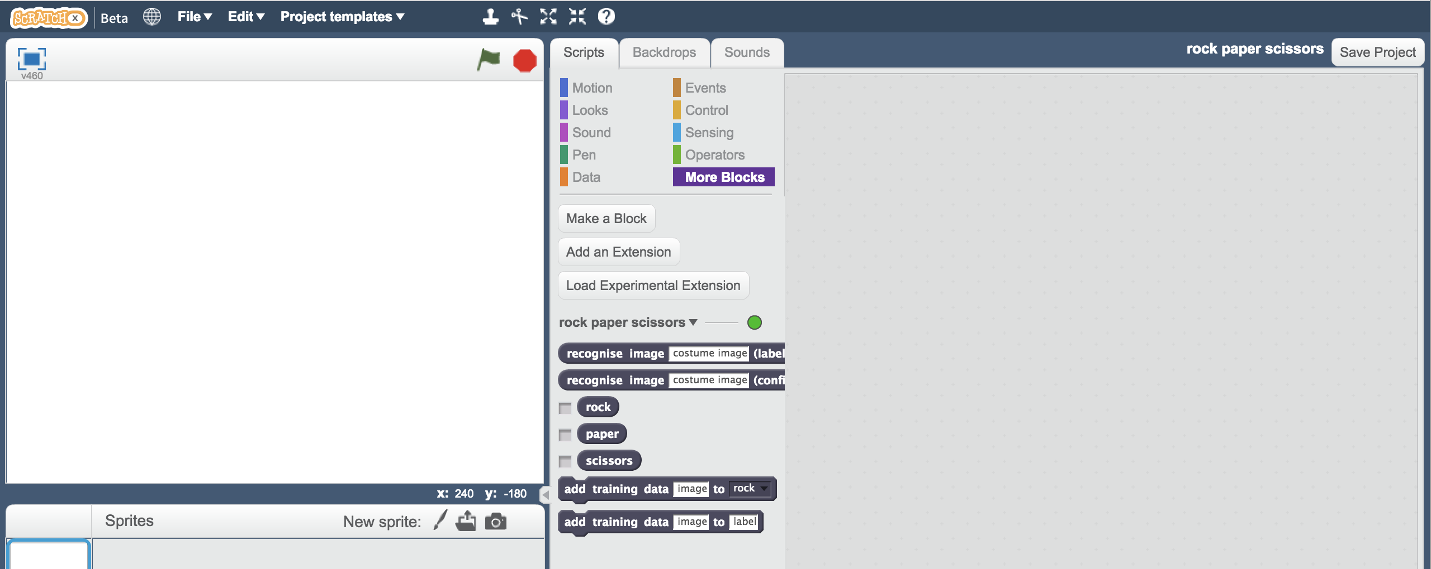

1. 開啟Rock, Paper, Scissors專案

*點選****Project templates，****再點選****Rock, Paper, Scissors***

Open the Rock, Paper, Scissors project template.   
*Click* ***Project templates*** *->* ***Rock, Paper, Scissors****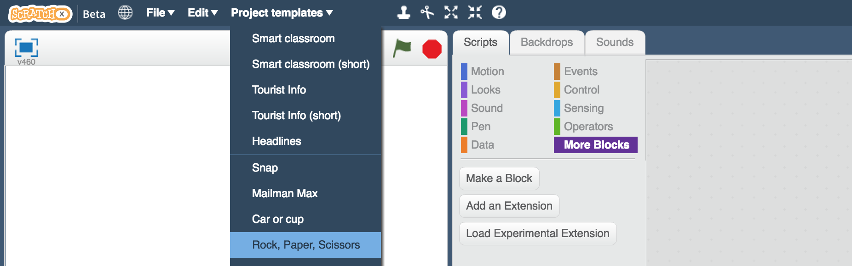*

1. 點選角色“**you**”

Click on the “**you**” sprite.  
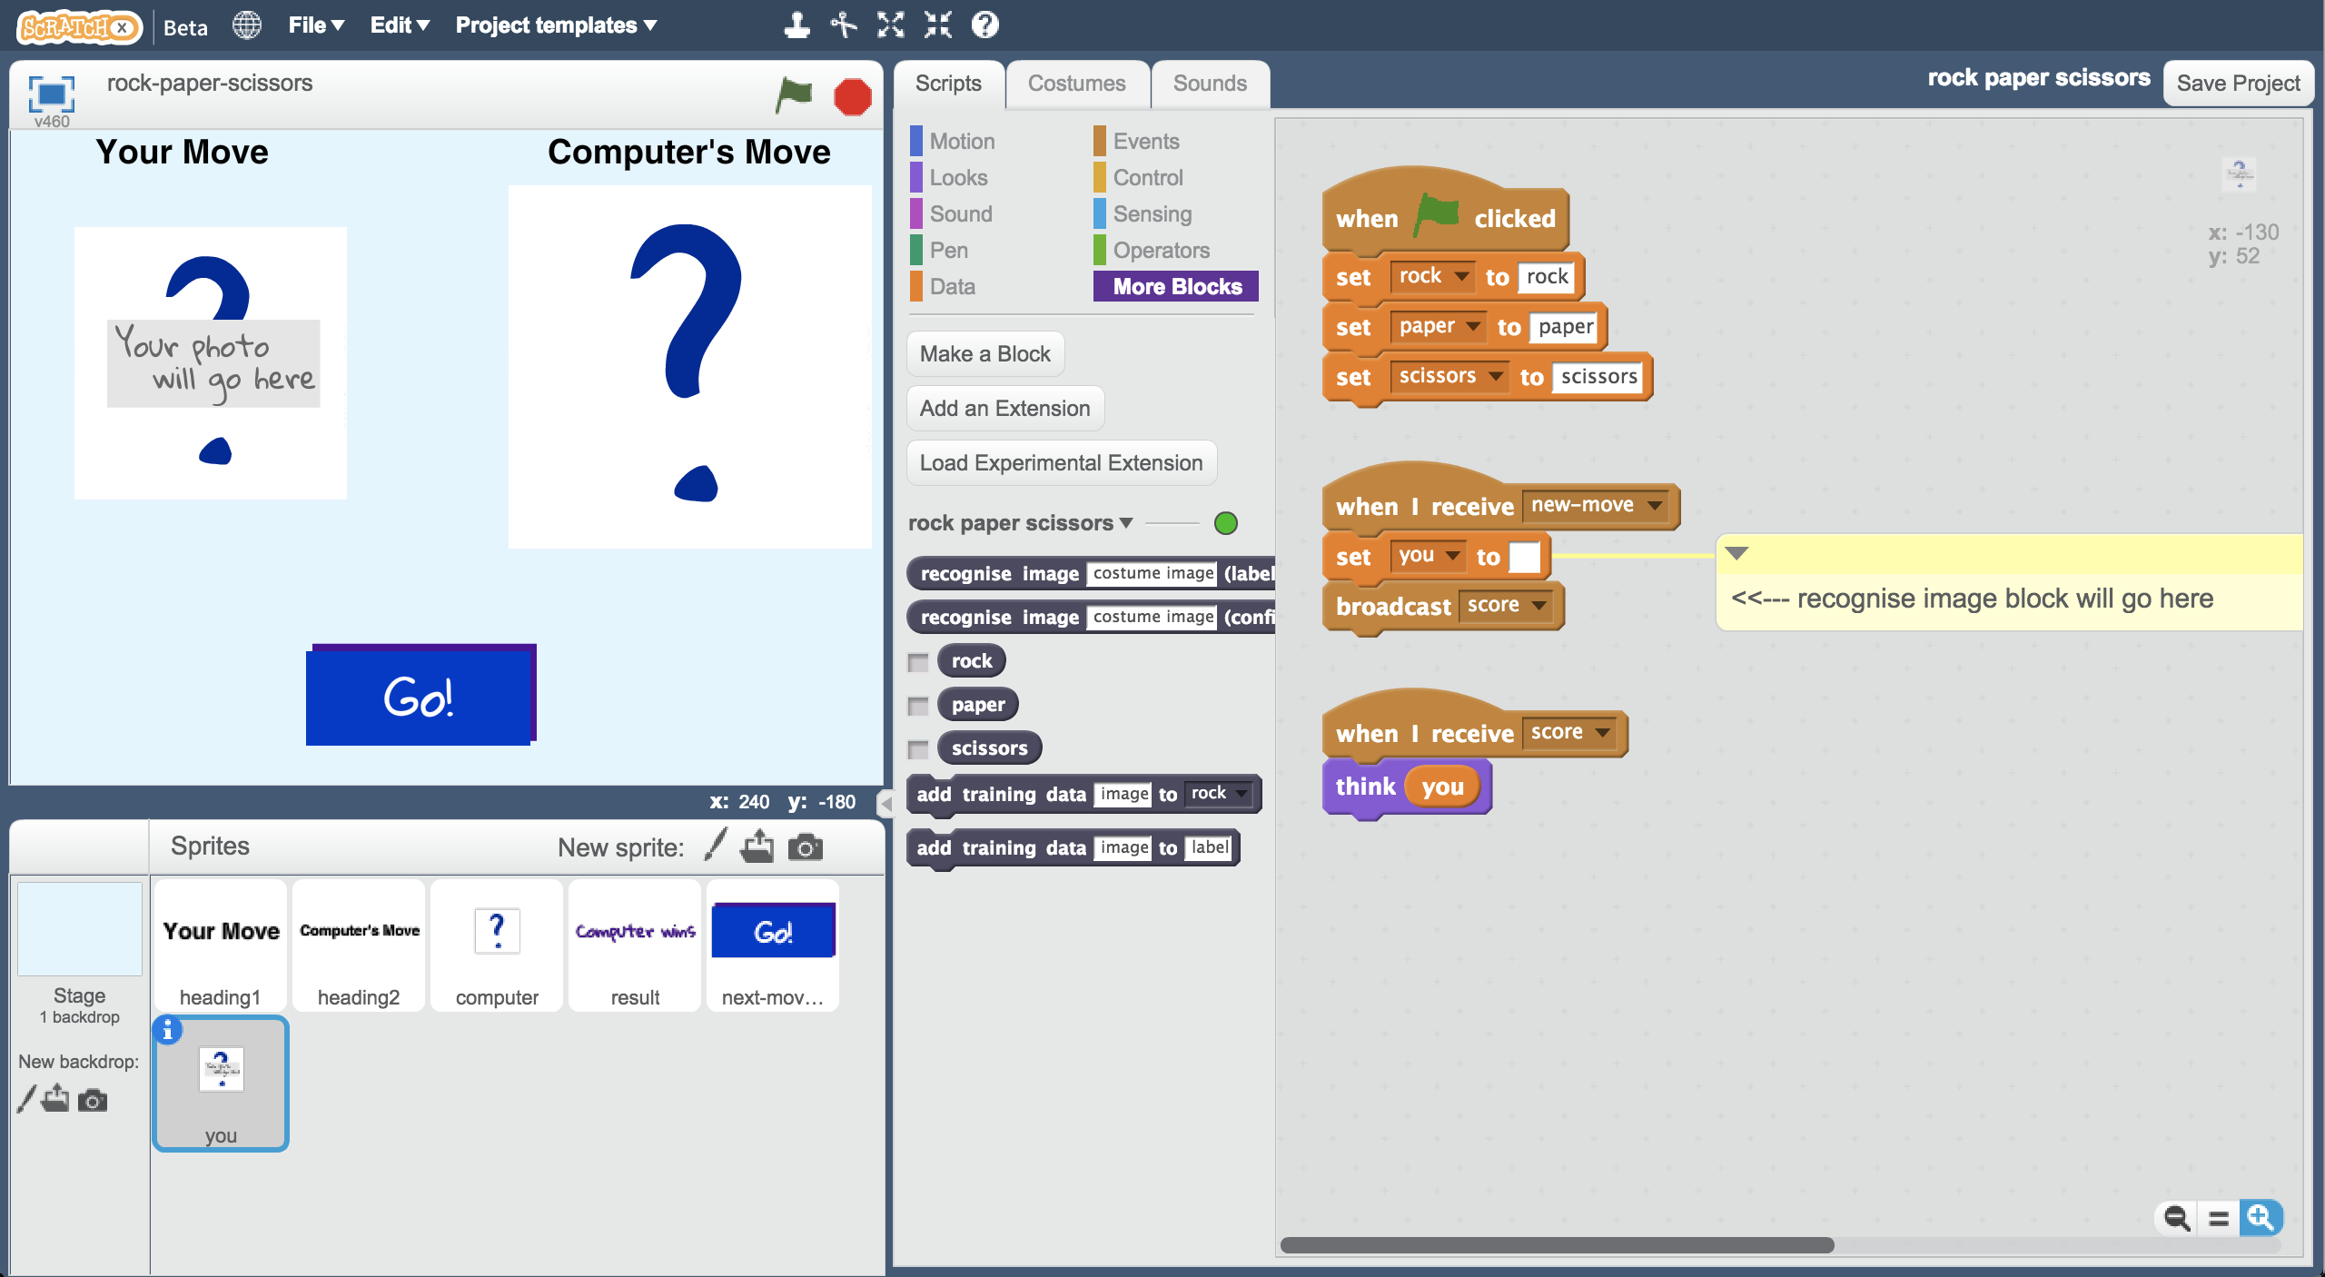

1. 更新**當綠旗被點擊**區域的程式（如下圖）

Update the **green-flag-clicked script** with your new project blocks  
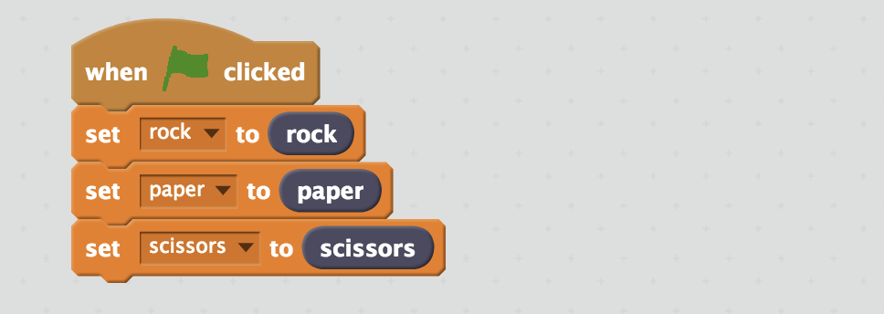

1. 更新**new-move**區域的程式

*加入“****recognise image****”和“****costume image****”積木*

Update the **new-move script**   
*Add the “****recognise image****” and “****costume image****” blocks*  
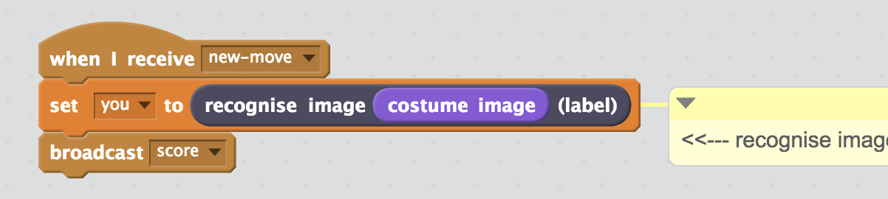

1. 點選『造型』

Click the “**Costumes**” tab  
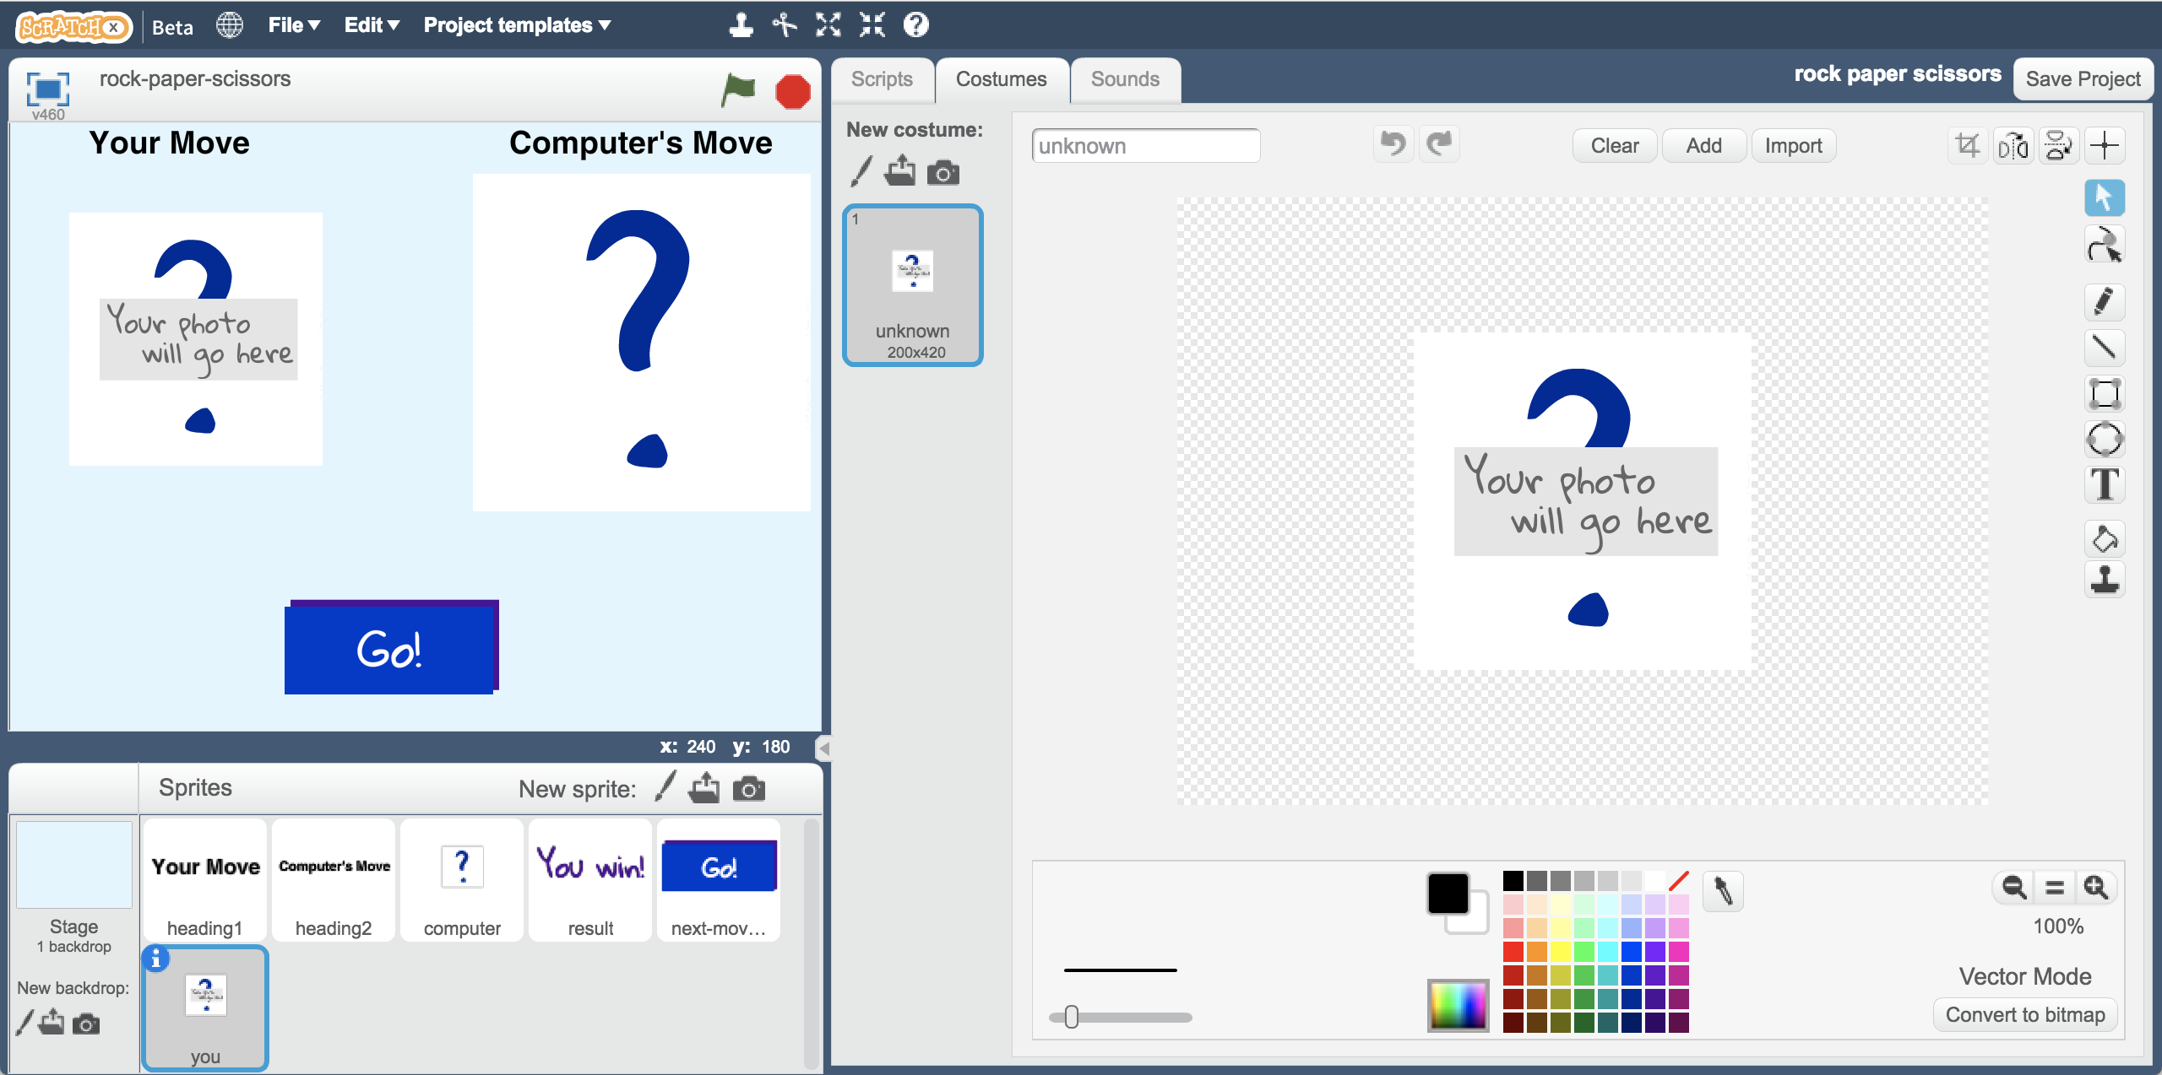

1. 選擇『從攝影裝置錄製新造型』

Click the “**New costume from camera**” button   
*It’s the camera icon shown below.*  
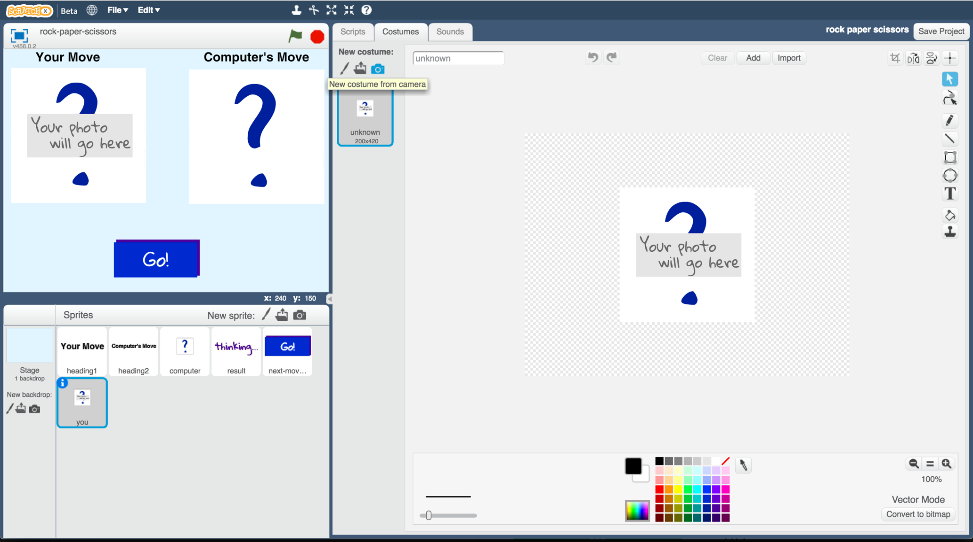

1. 拍張你手的照片

Take a photo of your hand  


1. 開始測試囉！

點擊綠旗，選擇“Go!”

電腦會隨機選張照片並辨識照片中的手勢，然後顯示可以贏得此局的手勢。

Test your project  
Click the **Green Flag**, then click the “Go!” button in the game.

*The computer will choose a random picture. It will try to recognise your hand shape, and then display who won.*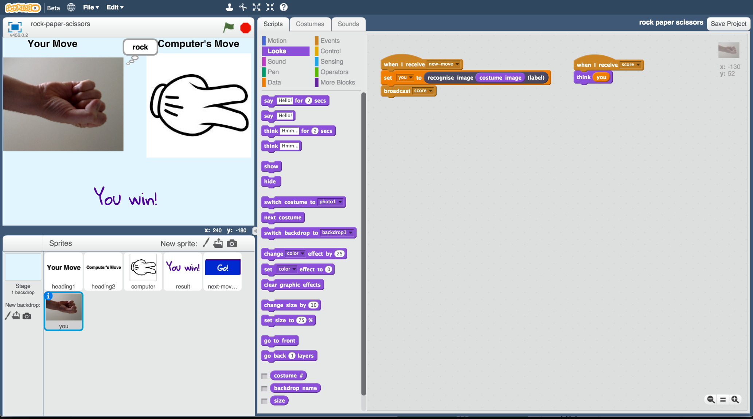

1. 如果電腦不能正確的辨別手勢，回到步驟21，加入更多範例照片。

新增範例後，記得要重複步驟24，重新訓練一個機器學習模型

If the computer is not very good at recognising your hand shapes, go back to step 21, and add more examples for the computer to learn from.   
You’ll need to repeat step 24 and train a new machine learning model after you’ve added more examples.

**你完成了什麼？**

**What have you done?**

你完成了一個簡單的Scratch版剪刀、石頭、布遊戲。這遊戲使用攝影裝置拍攝你的手，並用機器學習辨識照片中的手勢。

You’ve made a simple rock-paper-scissors game in Scratch.

The game uses a webcam to take pictures of your hand, and uses machine learning to understand the meaning of the photo.

這是『影像辨識』(image recognition)-教電腦辨別影像

This is “image recognition” – teaching a computer to recognise images.